USER STORIES

PERSONA | USER STORY | ACCEPTANCE CRITERIA
DIOMO KABONGO, the Troubled Congolese Youth Labourer | As a user, I want an app that is easy to download and requires low data to download so that I don’t have to worry about using up my data when downloading it. I don’t have much money or reliable airtime so I’d really use something more if it had no data cost. | - Downloadable with low data  - Easy to download  - Ideally no data cost
 | As a user, I want an app that can function offline so that I can use it when I have run out of data | - Usable online and offline  - Content/features including animated videos function offline  - Posts made as at the time of last online log in are visible offline
 | As a user, I want to register through another app like WhatsApp or Instagram so that I don’t need an email account to do registration. | - Multiple options for registering including email, WhatsApp and Instagram
 | As a user, I want to log in without putting in all my registration details so that I can log in even when I do not remember my registration details. | - Log in by simply clicking the app icon  - Password saved on app  - Password recovery option  - Multiple options for signing in
 | As a user, I want to have my photo on my profile and be able to edit my profile so I can change the photo whenever I want to. | - Upload profile photo  - View personal information  - Edit name  - Edit profile photo
 | As a user, I want an app that functions on a basic android phone so I can use it on my present handset | - Fully functional on any android phone
 | As a user, I want to be able to navigate the content so I can go straight to what I would like to read at any time. | - Functional search button  - Thumbnail image for content  - Ability to create bookmarks for fast access  - Click to see content
 | As a user, I want an app with cool designs and wordings so I can proudly use it in front of my friends | - Attractive design that looks cool to adolescents  - Wordings and slangs that adolescents use
 | As a user, I want to receive daily reminders to carry out recommended tasks so I can diligently do the tasks. | - Daily reminders for tasks  - Click to set reminders for specific tasks  - Click to set frequency and timings of reminders
 | As a user, I want an app that delivers relevant content in a fun and engaging format that is not too wordy so I can enjoy using the app. | - Engaging animated videos with relevant content  - Illustrations, minimal text  - Songs  - Upload mp3 songs and create a private song list
 | As a user, I want to share the content and my experiences with friends and family members so they can also learn from the app. | - Able to invite non-users  - Make posts  - Posts visible to other users
 | As a user, I want to record how often I follow the recommended practices and what results I see in my life and my family so that I may know if the app is helping my family and me. | - Assigned tasks for home practices  - Able to tick recommended practices /tasks carried out daily  - Able to record noticeable results in user’s life and/or family
 | As a user, I want to plan my budget and see my expenses so I can spend my money wisely. | - Record income  - List recurrent expense items and savings  - Allocate income to expense items  - Record expenses when made  - Review/see income and expenses made

PERSONA | USER STORY | ACCEPTANCE CRITERIA
ZAWADI MWANGI, the Bone-weary Kenyan Domestic Worker  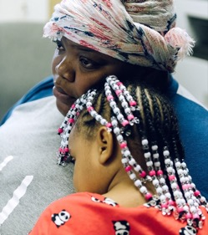 | As a user, I want an app that doesn’t take too much space on the phone and is easily downloaded with low data so that I don’t have to worry about using up my data when downloading it or about the app taking up too much space on my phone. | - Downloadable with low data  - Easy to download  - Ideally, no data cost  - Takes up relatively little space on the phone
 | As a user, I want an app that can function offline so that I can use it when I have run out of data and have no access to WiFi. | - Usable online and offline  - Content/features including animated videos function offline  - Posts made as at the time of last online log in are visible offline
 | As a user, I want a simple registration that allows me to register through WhatsApp and/or Facebook, and add my name and profile photo so that I can register without an email account. | - Register through WhatsApp or Facebook  - Add name to account  - Upload profile photo  - View personal information  - Edit name  - Edit profile photo
 | As a user, I can log in at any time without having to put in all my registration details every time so that I can log in even when I do not remember my registration details. | - Log in whether online or offline  - Log in by simply clicking the app icon
 | As a user, I want an app that functions on a basic Android phone so I can use it on my present handset. | - Fully functions on any Android phone
 | As a user, I want the parenting tips arranged in a format that allows me to see different topics or components so I can select what topic I need or would like to receive tips on at the time. | - See a thumbnail image for each session/topic  - Click to view details of each session/topic  - Search for a session/topic  - View parenting tips by sessions/topics  - Click to navigate to a particular session/topic
 | As a user, I want parenting tips that are effective and proven so I can be sure that when I apply them, they will have positive impact. | - Evidence-based content  - Effective content  - Content delivered in a manner that allows for M&E
 | As a user, I want an app with tasks that require different time spans so I can use it when I have short breaks at work and when I have longer time like when I am on the bus ride to or from work. | - Tasks that require short time to do  - Tasks that require medium time to do  - Tasks that require a longer time to do
 | As a user, I want to receive daily reminders to exercise so I can do my exercises every day. | - Daily reminders for tasks  - Click to set reminders for specific tasks  - Click to set frequency and timings of reminders
 | As a user, I want an app that delivers relevant content in a fun and engaging format that is not too wordy so I can enjoy using the app. | - Engaging animated videos with relevant content  - Illustrations, minimal text  - Songs
 | As a user, I want to share the content and my experiences with friends and family members so they can also learn from the app. | - Able to invite non-users  - Make posts  - Posts visible to other users
 | As a user, I want to record how often I follow the recommended practices and what results I see in my life and my family so that I may know if the app is helping my family and me. | - Sessions have assigned tasks for home practices  - Able to tick recommended practices/tasks carried out daily  - Able to record noticeable results in user’s life and/or family
 | As a user, I want to plan my budget and see my expenses so I can spend my money wisely. | - Record income  - List recurrent expense items and savings  - Allocate income to expense items  - Record expenses when made  - Review/see income and expenses made

PERSONA | USER STORY | ACCEPTANCE CRITERIA
OLUSEGUN ADEYEMI, the Successful Nigerian Banker   | As a user, I want to be known by a username that I select so that my identity remains private. | - Username selected by user  - Real name of user hidden to other users  - Username is what is seen by other users
 | As a user, I want a setting that can be kept private so that my personal details such as telephone number and email address are kept hidden except when or if I choose to reveal them. | - Setting has option of hiding personal details from other users  - Setting has option of allowing user to select personal details s/he wants seen by other users  - Setting has option of allowing user to select who sees personal details
 | As a user, I want a simple interface so that I can easily navigate and interact with the app. | - Thumbnail image for content  - Click to see content
 | As a user, I want to log in without putting in all my registration details so that I can log in even when I do not remember my registration details. | - Log in by simply clicking the app icon  - Password saved on app  - Password recovery option
 | As a user, I want the parenting tips arranged in a format that allows me to see different topics or components so I can select what topic I need or would like to receive tips on at the time. | - See a thumbnail image for each session/topic  - Click to view details of each session/topic  - Search for a session/topic  - View parenting tips by sessions/topics  - Click to navigate to a particular session/topic
 | As a user, I want parenting tips that are effective and proven so I can be sure that when I apply them, they will have positive impact. | - Evidence-based content  - Effective content  - Content delivered in a manner that allows for M&E
 | As a user, I want to receive reminders to praise my children so that I may do this on a regular basis. | - Reminders for tasks  - Click to set tasks you want reminders for  - Click to set frequency and timings of reminders
 | As a user, I want an app that delivers relevant content in an engaging format that is not too wordy so I can find it relaxing and enjoyable to use. | - Engaging videos with relevant content  - Illustrations, minimal text
 | As a user, I want to be able to share the app content and my experiences with friends or family members so they can also learn from the app. | - Able to invite non-users  - Make posts  - Posts visible to other users
 | As a user and a father, I want the app to have guidance on what may be posted so that there may be no bullying, threatening or indecent post. | - Rules on cyberbullying  - Users made to read cyberbullying rules after registration and before use of app
 | As a user, I want to track my engagement on the app so I can see what sessions I often use. | - Track of time spent on the app daily  - Track of sessions viewed daily  - Track of posts/comments made  - Track of cumulative time spent weekly and monthly
 | As a user, I want to record how often I follow the recommended practices and what results I see in my life and my family so that I may know if the app is helping my family and me. | - Sessions have assigned tasks for home practices  - Able to tick recommended practices/tasks carried out daily  - Able to record noticeable results in user’s life and/or family
 | As a user, I want to interact the app without seeing any ads so that I may maximize my time on the app. | - No ads on the app

PERSONA | USER STORY | ACCEPTANCE CRITERIA
BINTA SESAY, the Unhappy Sierra Leonean Waitress  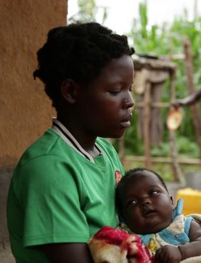 | As a user, I want an app that is easy to download and requires low data to download so that I don’t have to worry about using up my data when downloading it. I don’t have much money. | - Downloadable with low data  - Easy to download  - Ideally no data cost
 | As a user, I want an app that can function offline so that I can use it without worrying about data when I am not at work. | - Usable online and offline  - Content/features including animated videos function offline
 | As a user, I want to register through another app like WhatsApp or Instagram so that I don’t need an email account to do registration. | - Multiple options for registering including email, WhatsApp and Instagram
 | As a user, I want to log in without putting in all my registration details so that I can log in even when I do not remember my registration details. | - Log in by simply clicking the app icon  - Password saved on app  - Password recovery option  - Multiple options for signing in
 | As a user, I want to have my photo on my profile and be able to edit my profile so I can change the photo whenever I want to. | - Upload profile photo  - View personal information  - Edit name  - Edit profile photo
 | As a user, I want an app that functions on a basic android phone so I can use it on my present handset | - Fully functional on any android phone
 | As a user, I want to be able to navigate the content so I can go straight to what I would like to read at any time. | - Functional search button  - Thumbnail image for content  - Ability to create bookmarks for fast access  - Click to see content
 | As a user, I want an app that delivers content in a fun and engaging way with not so much text so I can enjoy using the app and understand the message. I don’t read very well and will like the text to be simple. | - Engaging animated videos with relevant content  - Illustrations, minimal text
 | As a user, I want an app with songs and videos that a child will enjoy listening to so that I can use the app even my I am carrying my daughter and she can enjoy it, too. | - Songs  - Engaging animated videos
 | As a user, I want to share the content and my experiences with friends and family members so they can also learn from the app. | - Able to invite non-users  - Make posts  - Posts visible to other users
 | As a user, I want an app with content on managing money so that I can learn to plan how I spend my money. | - Record income  - List recurrent expense items and savings  - Allocate income to expense items  - Record expenses when made  - Review/see income and expenses made

PERSONA | USER STORY | ACCEPTANCE CRITERIA
LINDIWE NGOBENI, the South African Pensioner Grandmother  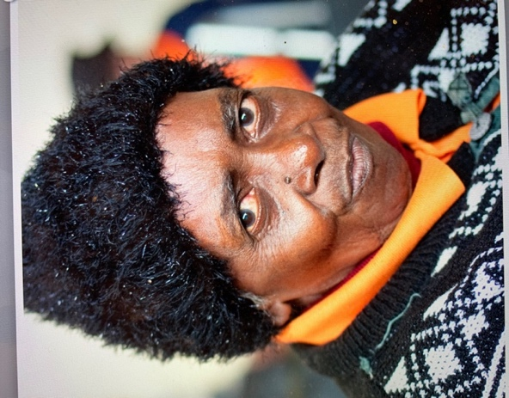 | As a user, I want an app that is easily downloaded with low data so that I don’t have to worry about using up my data when downloading it. | - Downloadable with low data  - Easy to download
 | As a user, I want an app that can function offline so that I can use it when I have run out of data and have no access to WiFi. Sometimes the electricity doesn’t work and so the WiFi is down. | - Usable online and offline  - Content/features including animated videos function offline
 | As a user, I want a simple registration that allows me to register through WhatsApp and/or Facebook so that I can register without an email account. | - Register through WhatsApp or Facebook  - Upload profile photo  - View personal information  - Edit name  - Edit profile photo
 | As a user, I can log in at any time without having to put in all my registration details every time so that I can log in even when I do not remember my registration details. | - Log in whether online or offline  - Log in by simply clicking the app icon
 | As a user, I want an app that reminds me to ‘take a pause’ when I am upset so that I do not make angry outbursts | - Button that sets off a ‘take a pause’ message when clicked  - Set reminders for ‘take a pause’ messages or similar messages
 | As a user, I want an app that functions on a basic android phone so I can use it on my present handset | - Fully functions on any android phone
 | As a user, I want the texts to be large, bold and in bright colours so that I can easily read them as I struggle to see well. | - Minimal text  - Texts should be big and in clear, bright colours
 | As a user, I want the parenting tips arranged in a format that allows me to see different topics or components so I can select what topic I need or would like to receive tips on at the time. | - See a thumbnail image for each session/topic  - Click to view details of each session/topic  - Search for a session/topic  - View parenting tips by sessions/topics  - Click to navigate to a particular session/topic
 | As a user, I want parenting tips that are effective and proven so I can be sure that when I apply them, they will have positive impact. | - Evidence-based content  - Effective content  - Content delivered in a manner that allows for M&E
 | As a user, I want to receive daily reminders to exercise so I can do my exercises every day. | - Daily reminders for tasks  - Click to set reminders for specific tasks  - Click to set frequency and timings of reminders
 | As a user, I want an app that delivers relevant content in an engaging format so I can participate and enjoy using the app. | - Engaging animated videos with relevant content  - Relevant exercises  - Illustrations, minimal text  - Songs
 | As a user, I want to share the content and my experiences with friends and family members so I can invite women in my church’s WhatsApp group to use the app or share what I am learning. | - Able to invite non-users  - Make posts  - Posts visible to other users
 | As a user, I want to record how often I follow the recommended practices and what results I see in my life and my family so that I may know if the app is helping my family and me. | - Sessions have assigned tasks for home practices  - Able to tick recommended practices/tasks carried out daily  - Able to record noticeable results in user’s life and/or family
 | As a user, I want to plan my budget and see my expenses so I can spend my money wisely. | - Record income  - List recurrent expense items and savings  - Allocate income to expense items  - Record expenses when made  - Review/see income and expenses made

PERSONA | USER STORY | ACCEPTANCE CRITERIA
CHIBALE BANDA, the Orphaned Malawian Boy  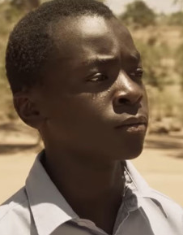 | As a user, I want an app that is easy to download and requires low data to download so that I don’t have to worry about using up my data when downloading it. My uncle doesn’t give me much money so I would want something that needs little or do data. | - Downloadable with low data  - Easy to download  - Ideally no data cost
 | As a user, I want an app that can function offline so that I can use it when I have run out of data | - Usable online and offline  - Content/features including animated videos function offline  - Posts made as at the time of last online log in are visible offline
 | As a user, I want to log in without putting in all my registration details so that I can log in even when I do not remember my registration details. | - Log in by simply clicking the app icon  - Password saved on app  - Password recovery option  - Multiple options for signing in
 | As a user, I want to have my photo on my profile and be able to edit my profile so I can change the photo whenever I want to. | - Upload profile photo  - View personal information  - Edit name  - Edit profile photo
 | As a user, I want an app that functions on a basic android phone so I can use it on my present handset | - Fully functional on any android phone
 | As a user, I want to be able to navigate the content so I can go straight to what I would like to read at any time. | - Functional search button  - Thumbnail image for content  - Ability to create bookmarks for fast access  - Click to see content
 | As a user, I want an app with cool designs and texts so I can proudly use it in front of my friends | - Attractive design that looks cool to adolescents  - Wordings and slangs that adolescents use
 | As a user, I want an app that with fun and engaging content so I can enjoy using the app. | - Engaging animated videos with relevant content  - Illustrations, minimal text
 | As a user, I want to share the content and my experiences with friends and family members so they can also learn from the app. | - Able to invite non-users  - Make posts  - Posts visible to other users
 | As a user, I would like content on family bonding so I can learn more about building a good relationship with my family | - Relevant content  - Evidence-based content  - Content that’s suitable for adolescents
 | As a user, I want the text to be in simple language so that I can easily understand it | - Text in simple language that’s easily understood by adolescents  - Language reflective of teen culture and country culture
 | As a user, I want an app that has exciting games so that I can play the games with my cousins and my friends | - Has fun and engaging games  - Has games for multiple players, at least more than person can play at a time

PERSONA | USER STORY | ACCEPTANCE CRITERIA
EFUA MENSAH, the Aspiring Ghanaian Actress   | As a user, I want an app that’s easy to download and doesn’t take too much space on the phone so that I don’t have to worry about what space is left on my phone. I have many apps on my phone so it’s important to me that an app doesn’t take too much space. | - Easy to download  - Takes up relatively little space on the phone
 | As a user, I want an app that can function offline so that I can use it when I have run out of data. | - Usable online and offline  - Content/features including animated videos function offline  - Posts made as at the time of last online log in are visible offline
 | As a user, I want my password saved when I register so that I don’t have to worry about remembering my password. | - Password saved on app  - Password recovery option
 | As a user, I want to log in without putting in all my registration details so that I can log in even when I do not remember my registration details. | - Log in by simply clicking the app icon  - Multiple options for signing in
 | As a user, I want to have my photo on my profile and be able to edit my profile so I can change the photo whenever I want to. | - Upload profile photo  - View personal information  - Edit name  - Edit profile photo
 | As a user, I want an app with emojis that express different emotions, something like Kimoji app, so that I can use emojis to show my feelings | - Has emojis for different emotions  - Users can post emojis
 | As a user, I want to be able to navigate the content so I can go straight to what I would like to read at any time. | - Functional search button  - Thumbnail image for content  - Ability to create bookmarks for fast access  - Click to see content
 | As a user, I want an app with cool designs and wordings so I can proudly use it in front of my friends | - Attractive design that looks cool to adolescents  - Wordings and slangs that adolescents use
 | As a user, I want an app that allows me to post photos so that I can share photos of myself and perhaps my family doing different tasks from the sessions | - Allows users to upload a limited number of photos  - Allows users to delete photos
 | As a user, I want to receive reminders to carry out recommended tasks so I can diligently do the tasks. | - Reminders for tasks  - Click to set reminders for specific tasks  - Click to set frequency and timings of reminders
 | As a user, I want an app that delivers relevant content in a fun and engaging format that is not too wordy so I can enjoy using the app. | - Engaging animated videos with relevant content  - Illustrations, minimal text  - Songs  - Dance videos (???)  - Upload mp3 songs and create a private song list
 | As a user, I want to share the content and my experiences with friends and family members so they can also learn from the app. | - Able to invite non-users  - Make posts  - Posts visible to other users
 | As a user, I would like an app that has role-playing games so that that I can play these with my parents and with my younger siblings, too. | - Has role-playing games  - Games to be played by multiple people

PERSONA | USER STORY | ACCEPTANCE CRITERIA
HUSSEIN IBRAHIM, the Struggling Sudanese Farmer   | As a user, I want an app that is easy to download and requires little or no data to download so that I don’t have to worry about using too much data when downloading it. | - Downloadable with low or no data  - Easy to download
 | As a user, I want an app that can function offline so that I can use it when I have run out of data or when the airtime is not reliable. | - Usable online and offline  - Content/features including animated videos function offline
 | As a user, I want to register through another app like WhatsApp or Instagram so that I don’t need an email account to do registration. | - Multiple options for registering including email, WhatsApp and Instagram
 | As a user, I want to log in without putting in all my registration details so that I can log in even when I do not remember my registration details. | - Log in by simply clicking the app icon  - Password saved on app  - Password recovery option  - Multiple options for signing in
 | As a user, I want an app that functions on a basic Android phone so I can use it on my present handset. | - Fully functions on any Android phone
 | As a user, I want a simple interface so that I can easily navigate and interact with the app. | - Thumbnail image for content  - Click to see content
 | As a user, I want the texts to be large and bold so that I can easily read them as I struggle to see well. | - Minimal text  - Texts should be big and in clear, bright colours
 | As a user, I want the parenting tips arranged in a format that allows me to see different topics or components so I can select what topic I need or would like to receive tips on at the time. | - See a thumbnail image for each session/topic  - Click to view details of each session/topic  - Search for a session/topic  - View parenting tips by sessions/topics  Click to navigate to a particular session/topic
 | As a user, I want parenting tips that are effective and proven so I can be sure that when I apply them, they will have positive impact. | - Evidence-based content  - Effective content  - Content delivered in a manner that allows for M&E
 | As a user, I want to receive daily reminders to do carry out recommended tasks so I can diligently do the tasks. | - Daily reminders for tasks  - Click to set reminders for specific tasks  - Click to set frequency and timings of reminders
 | As a user, I want an app with tasks that require different time spans so I can use it when I take short breaks in my farm and when I am resting at home. | - Tasks that require short time to do  - Tasks that require medium time to do  - Tasks that require a longer time to do
 | As a user, I want to have role-playing activities for parents and adolescents so that my children and I can go through those activities together. I want my children to also learn from the app. | - Has role-playing activities for parents and adolescents to do together
 | As a user, I want the app to have content that is culturally appropriate and not based on western ideas so that my children may not adopt western behaviours and rebel against our culture and traditions | - Culturally appropriate content
 | As a user, I want to share the content and my experiences with friends and family members so they can also learn from the app. | - Able to invite non-users  - Make posts  - Posts visible to other users
 | As a user, I want to plan my budget and see my expenses so I can spend my money wisely. | - Record income  - List recurrent expense items and savings  - Allocate income to expense items  - Record expenses when made  - Review/see income and expenses made

PERSONA | USER STORY | ACCEPTANCE CRITERIA
AÏSSATOU DIOP, the Brilliant Senegalese Academic  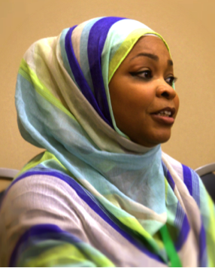 | As a user, I want to log in without putting in all my registration details so that I can log in even when I do not remember my registration details. | - Log in by simply clicking the app icon  - Password saved on app  - Password recovery option  - Multiple options for signing in
 | As a user, I want a setting that can be kept private so that my personal details such as telephone number and email address are kept hidden except when or if I choose to reveal them. | - Setting has option of hiding personal details from other users  - Setting has option of allowing user to select personal details s/he wants seen by other users  - Setting has option of allowing user to select who sees personal details
 | As a user, I want a simple interface so that I can easily navigate and interact with the app. | - Thumbnail image for content  Click to see content
 | As a user, I want the parenting tips arranged in a format that allows me to see different topics or components so I can select what topic I need or would like to receive tips on at the time. | - See a thumbnail image for each session/topic  - Click to view details of each session/topic  - Search for a session/topic  - View parenting tips by sessions/topics  - Click to navigate to a particular session/topic
 | As a user, I want parenting tips that are effective and proven so I can be sure that when I apply them, they will have positive impact. | - Evidence-based content  - Effective content  - Content delivered in a manner that allows for M&E
 | As a user, I want to receive reminders to ‘take a pause’ when upset, and to praise my children so that I may do this on a regular basis. | - Reminders for tasks  - Click to set tasks you want reminders for  - Click to set frequency and timings of reminders
 | As a user, I want an app that delivers relevant content in an engaging format so I can find it relaxing and enjoyable to use. | - Engaging formats  - Relevant content
 | As a user, I want to record how often I follow the recommended practices and what results I see in my life and my family so that I may know if the app is effective. | - Assigned tasks for home practices  - Able to tick recommended practices /tasks carried out daily  - Able to record noticeable results in user’s life and/or family
 | As a user, I want an app with tasks that require different time spans so I can use it when I have short free periods in my office and when I have longer free time at home. | - Tasks that require short time to do  - Tasks that require medium time to do  - Tasks that require a longer time to do
 | As a user, I want some fun, exciting, participatory activities or games that parents and adolescents can do or play together so that my children and I can do something fun together and learn while at it. | - Has exciting activities that parents and adolescents can do together  - Has fun games that adolescents and parents can play together  - Activities and games are didactic but fun and engaging
 | As a user, I want to share the content and my experiences with friends and family members so they can also learn from the app. | - Able to invite non-users  - Make posts  - Posts visible to other users
 | As a user, I want to interact with the app without seeing many ads so that I may maximize my time on the app. I also want the featured ads to be relevant to parenting or motherhood. | - Few ads on the app  - Ads should be relevant  - Ad content should be appropriate for both adult and adolescent consumption
 | As a user, I want the app to have content and illustrations that are culturally appropriate and in line with my religious beliefs so that my children may not learn behaviours that are abhorrent in our faith or imbibe beliefs that oppose our faith. | - Culturally appropriate content  - Content that are in agreement with all faiths/religious views
 | As a mother, I want the app to have guidance on what may be posted so that there may be no bullying, threatening or indecent post. | - Rules on cyberbullying  - Users made to read cyberbullying rules after registration and before use of app
 | As a user, I want to record how often I follow the recommended practices and what results I see in my life and my family so that I may know if the app is helping my family and me. | - Assigned tasks for home practices  - Able to tick recommended practices /tasks carried out daily  - Able to record noticeable results in user’s life and/or family

PERSONA | USER STORY | ACCEPTANCE CRITERIA
HENRI MBA, the Conflicted Gabonese Teenage Father  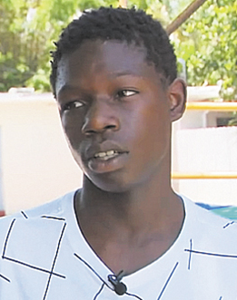 | As a user, I want an app that is easy to download and requires low data to download so that I don’t have to worry about using up my data when downloading it. I don’t have much money or reliable airtime so I would like something I can use with little or no data. | - Downloadable with low data  - Easy to download  - Ideally no data cost
 | As a user, I want an app that can function offline so that I can use it when I have run out of data. | - Usable online and offline  - Content/features including animated videos function offline  - Posts made as at the time of last online log in are visible offline
 | As a user, I want to register through another app like WhatsApp or Instagram so that I don’t need an email account to do registration. | - Multiple options for registering including email, WhatsApp and Instagram
 | As a user, I want to log in without putting in all my registration details so that I can log in even when I do not remember my registration details. | - Log in by simply clicking the app icon  - Password saved on app  - Password recovery option  - Multiple options for signing in
 | As a user, I want to have my photo on my profile and be able to edit my profile so I can change the photo whenever I want to. | - Upload profile photo  - View personal information  - Edit name  - Edit profile photo
 | As a user, I want an app that functions on a basic android phone so I can use it on my present handset | - Fully functional on any android phone
 | As a user, I want to be able to navigate the content so I can go straight to what I would like to read at any time. | - Functional search button  - Thumbnail image for content  - Ability to create bookmarks for fast access  - Click to see content
 | As a user, I want an app with cool designs and texts so I can proudly use it in front of my friends | - Attractive design that looks cool to adolescents  - Wordings and slangs that adolescents use
 | As a user, I want an app with interesting and fun content including some pop songs without too much text so that I can have fun while using the app. | - Engaging animated videos with relevant content  - Illustrations, minimal text  - Pop Songs
 | As a user, I want to share the content and my experiences with friends and family members so they can also learn from the app. | - Able to invite non-users  - Make posts  - Posts visible to other users
 | As a user, I want reminders on tasks so that I can carry out the different tasks assigned in the app | - Reminders for tasks  - Click to set tasks you want reminders for  - Click to set frequency and timings of reminders
 | As a user, I want an app that could show me my expenses and help me plan how I spend my money so that I can monitor my expenses and how much money I send for my son’s upkeep. I also want to start saving for his future. | - Record income  - List recurrent expense items and savings  - Allocate income to expense items  - Record expenses when made  - Review/see income and expenses made

PERSONA | USER STORY | ACCEPTANCE CRITERIA
ANA LUKAMBA, the Zealous Angolan Women’s Fellowship President  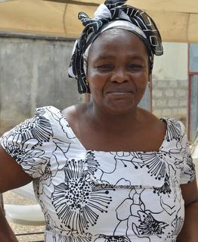 | As a user, I want an app that regularly provides me with effective relationship tips so that I can always have new information to share with the women in my church. | - Updated periodically with new content  - Updated periodically with modified versions of old content
 | As a user, I want to occasionally share bits of the app content on the Women’s Fellowship WhatsApp group so that members of the group can be enriched through the app. | - Some content/segment can be copied and shared with contacts on social media (DO WE WANT TO DO THIS? COULD BE A WAY TO ADVERTISE THE APP TO NON-USERS IF THE SHARED BITS ARE BRANDED)

PERSONA | USER STORY | ACCEPTANCE CRITERIA
HAROUNA DAOUDA, the Devoted Nigerien Researcher   | As a user, I want an app that delivers an intervention that is targeted at Sub-Saharan African communities so that I can learn more about the effectiveness of digital interventions in Sub-Saharan Africa | - Designed for Sub-Saharan Africa  - Provision for language modification  - Works offline and online
 | As a user, I want an app that automatically tracks outcomes, so that I can see the impact of the intervention in the users | - Tracks time spent by user on different segments  - Tracks tasks completed by user  - Tracks user’s outcomes per category/topic  - Compares time spent on app and tasks completed with outcomes

PERSONA | USER STORY | ACCEPTANCE CRITERIA
VIMBAI MOYO, the Bubbly Zimbabwean PLH Facilitator  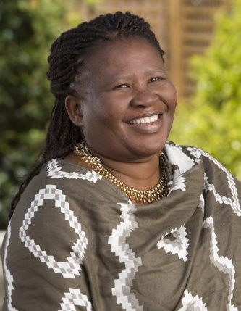 | As a user, I want an app that I could sometimes use to facilitate the PLH sessions so that I don’t have to do all the facilitation on my own all through each session | - Can be used by one person and in a group  - Has built-in group activities  - Speakerphone feature
 | As a user, I want an app that participants of the PLH programme can use all the time so that they may receive reminders to do tasks and also continue receiving the PLH programme even when they have completed the 14 sessions. | - Content same/similar to that delivered during in-person facilitation  - Reminders for tasks
 | As a user, I want an app that tracks programme outcomes, so that I could have the satisfaction of knowing that users of the app are benefiting from the PLH programme in the same way that participants of the in-person PLH programme benefit from the programme. | - Tracks time spent by user on different segments  - Tracks tasks completed by user  - Tracks outcomes

PERSONA | USER STORY | ACCEPTANCE CRITERIA
GAHIJI UWIMANA, the Rwandan M&E Officer  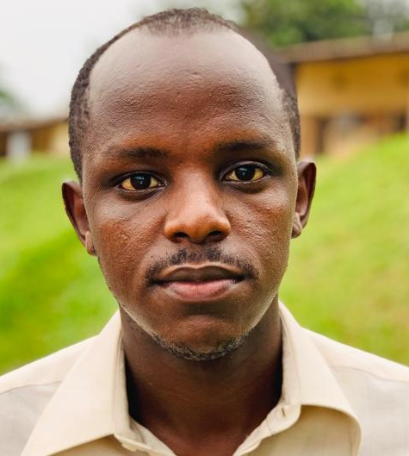 | As a user, I want an app that collects data of users so that we can lessen the large number of paper forms that we use across our different programmes. | - Collects demography/personal data of users  - Categorizes and compares personal data of users
 | As a user, I want an app that collects and verifies routine monitoring data so that I can easily access accurate data to report to funders. | - Collects and verifies routine monitoring data  - Compares monitoring data versus time spent on app  - Provides periodic monitoring data  - Tracks changes in monitoring data
 | As a user, I want an app that automatically tracks programme outcomes, so that our NGO doesn’t need to find additional funds to implement programme evaluations. | - Tracks time spent by user on different segments  - Tracks tasks completed by user  - Tracks user’s outcomes per category/topic  - Compares time spent on app and tasks completed with outcomes

